Lighter aircraft and quicker production ahead with Multifunctional Fuselage Demonstrator

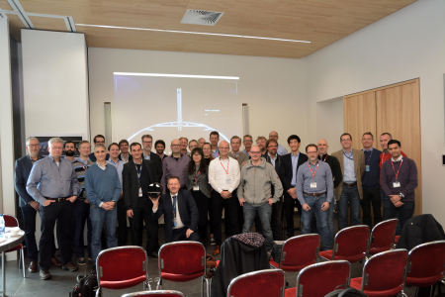

26 November 2019

The Multifunctional Fuselage Demonstrator, part of Clean Sky 2’s Large Passenger Aircraft platform, has reached an important milestone with the successful passing of its Critical Design Review at a two-day meeting held in Bremen on 18-19 November. The consortium working on the demonstrator underlined their commitment to deliver an 8-metre long thermoplastics fuselage barrel by the end of the Clean Sky 2 programme, which will be the first of its kind in the world.

The demonstrator aims to enable production rates of at least 60 large passenger aircraft per month, while reducing fuselage weight by 1 ton with a reduction of recurring costs. This in turn would bring significant fuel-burn reductions — and therefore reduction in the CO2 and NOx footprint — by substantially reducing the overall aircraft energy consumption due to lower weight systems and improved system architecture integration.